Floractive x Website Comments 1
Sept 2

- Need to update Branding
  - Colors
    - Avoid black
    - Let’s use neutral colors, browns, tan, white can also work (I google salon vibes for pegs)
  - Fonts
    - Title: Playfair Display
    - Auxilary Typography – Poppins (Bold?)

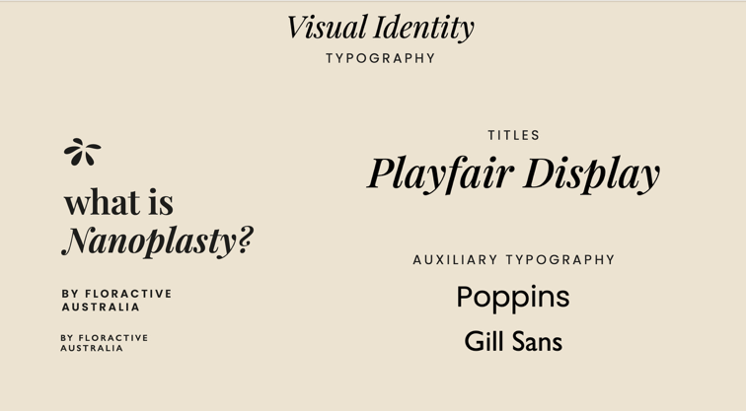
  - Bold Categories

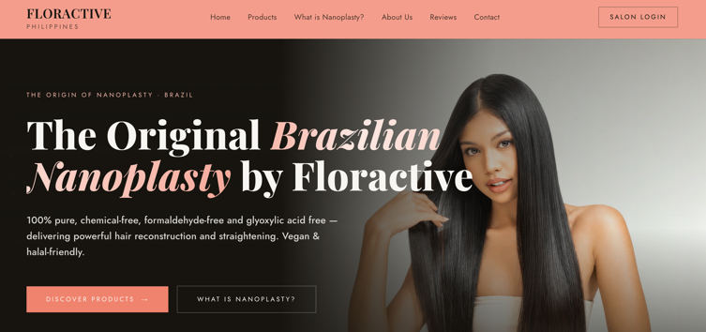

- IG Handles – put in a more obvious area – maybe in the top, not in the side of the website, also too small.
  - FB link: https://www.facebook.com/floractivephilippines
  - IG link: https://www.instagram.com/floractivephilippines/
  - Tiktok link: @floractivephilippines

- Order of Categories:

  - Home
  - What is Nanoplasty?
  - Products
  - About Us
  - Reviews
  - Contact
  - Salon login or Salon Partners? (not sure if we will keep this on the first phase)

- What is Nanplasty ? Copy

What is Nanoplasty by Floractive?

Floractive's Nanoplasty is the original solution, introduced to the Australian market by MJ and Sam in 2019. Originally called Nanoplastia, the name was later changed to better suit English-speaking countries. Today, it has become a widely recognized and popular hair straightening solution.

Nanoplasty by Floractive is an exclusive and innovative hair straightening treatment that utilizes nanotechnology to achieve smooth, frizz-free hair without causing damage. Unlike traditional keratin treatments, Nanoplasty employs nanoparticles combined with intracellular nutrition to penetrate deep into the hair fiber, delivering essential nutrients without the need to open the cuticle. This approach not only straightens the hair but also enhances its health and shine.

The treatment is formaldehyde-free and incorporates natural, organically sourced
ingredients, making it a vegan-friendly option. Depending on the specific product variant, such as W Two Plex, designed for blonde and grey hair, the formula may include components like:

•⁠ ⁠Ultraviolet pigments to neutralise unwanted tones
•⁠ ⁠Ojon Oil for hydration
•⁠ ⁠Hydrolysed vegetable keratin
•⁠ ⁠Essential amino acids

- Products
  - Straightening
    - W One
      - Remove 300 ml
      - Remove 120 ml
    - WTWO Plex
      - Remove 120 ml
    - Add Gloss Protein (Currently glass protein – kindly correct to Glass Protein – 100 ml)
  - Reconstruction
    - Force Therapy
      - Remove 300 ml
  - Treatment
    - Move here: Macadamia Natural Oil
    - Move here: 20 Vinte1
    - Move here: Thermal Protector – 120 ml
    - Update: Golden Gloss Protein (Not Glass)
  - Home Care
    - Add W1 Shampoo – 300 ml
    - W1 3in1 – 300 ml
    - Moringa Oil – 60 ml
    - Gloss Protein Shampoo – 300 ml
    - Gloss Protein Mask – 250 ml
  - Remove Finishing Category

- About Us Copy
  - Update –

About Us

The Official Floractive Team in the Philippines

As the Official Floractive team in the Philippines, we bring Floractive’s professional hair technology directly to the local salon industry through authentic products, expert education, certification, and dedicated local support.
We bring Floractive’s advanced Brazilian hair technology and professional salon solutions to the Philippine market, giving salons access to globally recognized innovation backed by education and expertise.
We believe the Philippine market deserves world-class hair treatments that deliver exceptional results while embracing a more modern approach to professional hair care. With our tropical climate, high humidity, and the everyday challenges of frizz and unruly hair, Floractive’s Nanoplasty technology offers an innovative solution for smoother, straighter and beautifully manageable hair.

International Standards & Quality
Floractive’s commitment to quality is supported by internationally recognized standards and certifications, including:
Halal Certification
Floractive’s ingredients, raw materials and manufacturing processes are assessed according to recognised Halal standards, reinforcing the brand’s commitment to quality and responsible product formulation.
ISO 9001 Certification
Reflects Floractive’s commitment to internationally recognized quality management standards, consistent processes and continuous improvement.

Global Innovation, Now in the Philippines
With a presence in more than 100 countries worldwide, Floractive has become an internationally established name in professional hair care.
Today, we are proud to bring the Floractive experience to salons across the Philippines — with genuine products, professional education, hands-on training and certification, backed by a dedicated local team.

- Reviews – to follow or hide?

- Contact Us
  - floractive@filiamph.com
  - Remove:
    - For Salons: Wholesale Inquiries
  - Update:
    - The original Brazilian Nanoplasty …to:
Exceptional service is at the heart of the Floractive experience. Whether you’re looking for expert product advice, professional support, or simply have a question, our dedicated team is always happy to assist.
Get in touch with us through our distributor FILIAM Business Ventures Inc.:
Email: floractive@filiamph.com
Facebook: Floractive Philippines
We look forward to hearing from you.
